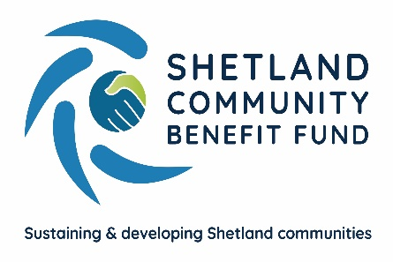
Viking Community Fund
One-off Fund open to Shetland’s Community Halls

1 Key Points

This initial one-off fund is financed from bank interest earned by the Viking Community Fund in 2025/26.

All applications are to be submitted directly to SCBF administration by Sunday 15th February 2026 and will be appraised by SCBF staff and allocated funding by a panel of SCBF directors.

2 How much funding is available from scheme and how much funding will we receive if successful?

The funding pot is estimated to be in the region of £50,000 and SCBF directors will make a total of 5 awards from the fund.

3 What can grants be used for?

Grant requests can support a wide range of costs and activities, for example equipment costs, maintenance, or refurbishment of community halls. Grant requests for running costs will not be processed, i.e. insurance, utility bills etc.

Applications need to:

- Sustain and develop the local community
- Represents value for money – evidence that the project has a high impact for the amount of grant
- Show community involvement – evidence that the community is engaged in the development and implementation of the project
- Is financially viable – evidence that the project will be maintained beyond the period of grant funding (if applicable)

4 Who can apply

The fund is only open to community halls in Shetland. Applications from other community buildings will not be accepted. To apply you need to supply the following documents along with your application

- Governing document (constitution or set-of rules)
- Annual accounts or an income and expenditure statement for the most recent financial year
- A bank account statement dated within the last 4 months bearing the name of your community hall
- Quotes for any equipment or project costs (if relevent)

Applications received without the requested supporting documentation will not be considered.

5 When will I hear if we have secured funding and if successful, payment made?

Applicants to the fund will be advised of an outcome in early March 2026. If successful, your award will be paid on or around the 31st of March 2026.

6 Will our community hall still be able to apply to the Viking Community Fund Community Grant Scheme (CGS) if successful in receiving funding from this fund?

Yes, you will still be able to apply to the Viking Community Fund CGS for the same, or a different project in 2026.

7 SCBF contact details

You can contact the SCBF Fund Manager, Eleanor Gear or the SCBF Senior Administration Officer, Emma McKay by emailing admin@scbf.org.uk

Alternatively, you can call us,

Eleanor Gear – 07538 417 175
Emma McKay – 07785 991 945

