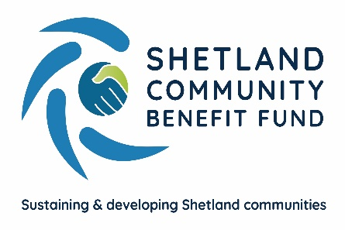
Viking Community Fund
Community Halls one-off Grant Fund
Application Form

Name
I am applying on behalf of:
Contact Name and address with postcode
Telephone number
Contact email
Is this a new or existing project?

Please describe the project you are looking for funding for.
Maximum word limit 250 words
How much does your project cost? | £
Have you secured any other funding towards your project? If yes, please provide brief details
Checklist
I have included the following documents with my application: | Yes | No
A signed copy of the organisation’s constitution/set of rules
Latest annual accounts or income and expenditure statement
A copy of a Bank Statement dated within the last 4 months
Project budget plan and/or quotes (if applicable)

Signed: ....................……………………………………….. Date: ……………………………………………….

GDPR
Personal Data collected through this application will be used for the purposes of administering your grant and, if successful, it may also be used to promote the SCBF grant scheme. Further details on how we will use your Personal Data, who we share it with and your rights under GDPR can be found in our Privacy Statement
--------------------------------------------------------------------------------------------------------------------------

For SCBF Use Only: Reference___________ Date Received: ______________

