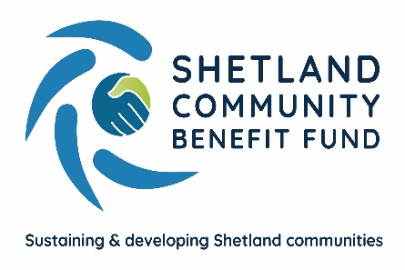

Viking Community Fund
Tier 1, Tier 2 and Tier 3 Application Guidelines

Contents Page

1 | Key Points | 3
2 | How much funding is available from the Community Grant Scheme (CGS)? | 3
3 | What can grants be used for? | 3
4 | Who can apply? | 4
5 | How much can I apply for? | 4
6 | When are decisions made? | 4
7 | What activities can not be supported | 5
8 | How many times can I apply? | 5
9 | When must grants be spent by? | 6
10 | SCBF contact details | 6
Appendix A | Guidance on completing the online application | 7

1 Key Points

The Community Grant Scheme is financed from the Viking Community Fund.

There will be three tiers of funding. Tiers 1 and 2 are considered by community councils and Tier 3 will be considered directly by SCBF.

All applications are submitted directly to SCBF administration to be checked and for due diligence to be completed. Tier 1 and Tier 2 applications are then shared with the relevant community council. Tier 3 applications are appraised by staff and allocated funding by an SCBF funding panel.

2 How much funding is available from the Community Grant Scheme (CGS)?

The CGS has an overall annual funding pot of £356,500.

£221,500 will be divided between all Shetland community council areas, with the four areas that have a Viking wind turbine within their boundary receiving five shares and the other 14 receiving one share.

- 1 share area = £6,515
- 5 share area = £32,575

1 share areas – Bressay, Burra and Trondra, Dunrossness, Fetlar, Gulberwick, Quarff & Cunningsburgh, Lerwick, Northmavine, Sandness and Walls, Sandwick, Scalloway, Skerries, Unst, Whalsay and Yell.

5 share areas – Delting, Nesting and Lunnasting, Sandsting and Aithsting and Tingwall, Whiteness and Weisdale.

Tier 3 has a funding pot of £135,000 annually and the fund will open 3 times per year.

3 What can grants be used for?

Grant requests can support a wide range of costs and activities, for example equipment costs, consultations, maintenance, or refurbishment of community facilities etc.

Applications for community-focussed or charitable activities need to:

- Sustain and develop the local community
- Represents value for money – evidence that the project has a high impact for the amount of grant
- Show community involvement – evidence that the community is engaged in the development and implementation of the project
- Is financially viable – evidence that the project will be maintained beyond the period of grant funding (if applicable)

4 Who can apply

Groups or organisations which need funding to support projects or activities consistent with the purposes listed above may apply for a grant.

For applications over £1,000 your organisation must have a constitution (governing document or set of rules) and be set up on a not-for-profit basis. You don’t need to be a registered charity to apply.

5 How much can I apply for?

Projects within individual or across 3 community council areas
Tier 1 application – £50 and £1,000
Tier 2 application – £1,001 and above*

Shetland-wide projects
Tier 3 application – £200 to £15,000

*there is no upper limit, however, community councils can not draw-down more than 5 years of future funding and consideration should be given to their available funds. Contact SCBF if unsure.

SCBF encourage all applicants not to request 100% of project costs but to also seek additional funding from alternative sources to complete the funding package required for the project.

6 When are decisions made?

Tier 1 and Tier 2

SCBF aim to return decisions on applications within 8 weeks of receiving them. However, you will be advised as soon as possible if the community council you are applying to anticipate any delay to this timescale. The fund cannot support retrospective funding, i.e. paying for costs incurred before a decision on an application to the Fund for support can be made. Therefore, please ensure your application is submitted with enough time for a decision to be made before your project takes place.

Tier 3

Deadline | Panel Meets
30th September | Mid-November
31st January | Mid-March
31st May | Mid-July

For applications to the Tier 3 fund, SCBF will contact you within two weeks of the panel meeting date to let you know whether your application has been successful or not.

7 What activities can not be supported by the fund

- Projects primarily benefiting residents outside Shetland.
- The advancement of religion or party politics.
- Activities that are generally understood to be the exclusive responsibility of a statutory authority.
- Activities contrary to the interests of VEWF or its affiliates.
- Activities likely to bring VEWF or its subsidiaries into disrepute.
- Anti-renewable energy/wind farm activities.
- Trips abroad unless for educational purposes.
- General fundraising appeals or activities.
- Retrospective funding (i.e. paying for costs incurred before a decision on an application to the Fund for support can be made).
- Individuals for their direct gain
- The purchase of firearms
- Fees for performing at an event
- Fees for professional media broadcasting of an event

8 How many times can I apply

Tier 1 and Tier 2

- You can apply for more than one Tier 1 grant per year, up to a total value of £2,000, but not towards the same expense (the year begins from the date of your first successful grant offer letter)
- You can apply for one Tier 2 grant per year (a year is defined as 12 months from the date on your last successful grant offer) but not towards the same expense as a Tier 1 grant.
- You can apply for the same project if 12 months have passed since you were last awarded funds for that project, however, be aware, repeat applications may gather less support. Projects, where appropriate, should be self-sustaining.

Tier 3

- You can only apply once annually to the Tier 3 fund. If you have successfully secured an award, you must wait 12 months from the date on your last successful grant offer letter before reapplying.
- You can apply for the same project if 12 months have passed since you were last awarded funds for that project, however, be aware, repeat applications may gather less support. Projects, where appropriate, should be self-sustaining.

9 When must grants be spent by

All awardees must be able to meet grant conditions detailed within their grant offer letter. Grants should be spent within 12 months of grant award. However, any project delays should be communicated to SCBF, and a grant extension may be agreed.

10 SCBF contact details

Email – admin@scbf.org.uk

Telephone – Emma McKay, SCBF Administration Officer 07785 991 945

Appendix A – Guidance on completing the online application

Before you begin

All sections of the online application must be completed, and you must upload the other documents we require for due diligence. To give your application the best chance of success, please be concise in your answers to ensure the key information and details of your project are captured. A full list of questions for the online application are included in this appendix.

About the online application process

- You will be asked to create a user account on our website prior to completing an online application.
- The user account will be personal to you and you will be able to submit applications for multiple organisations from a single login account.
- Your application will automatically save as you progress through it.

General Guidelines

- Please complete all relevant sections. You will be unable to move through the online application where a mandatory field hasn’t been completed.
- In order to give your application the best chance of success, please provide as much information as possible for each section but be concise so as not to lose the essence of what your project is about.
- Please don’t write ‘see attached’ on any part of the form as a substitute for information – although if you wish to include other documents (besides your constitution and accounts) with which to support and supplement your application then you are welcome to do so. These can be added at the end by uploading ‘additional supporting documents’.
- Please round figures up to the nearest pound.
- If your project is time specific, then please make sure your application is made in plenty of time to receive a decision before the project takes place.
- SCBF is a Living Wage Friendly Funder; therefore, we would expect any roles paid for through a grant to meet or exceed the Living Wage. If it does not, then we can work with you to find a solution to this. Please see the Living Wage website http://www.livingwage.org.uk/friendly-funders.

Contact Details

- Make sure the main contact is familiar with both the workings of the organisation and the grant application, as this person may be contacted for further information. Please make sure they will be available in the six weeks following the next deadline and let us know if they are away for any time during this period.

Governing Document

- Groups applying for funding up to £1,000 are not required to have a governing document (constitution or set of rules).
- Applications above £1,001 can only be considered from constituted groups. The name of your group should be the name written on your constitution (or governing document). You must send us a copy of your signed constitution with your application.
- Your type of organisation will be the legal status of your organisation e.g., a company limited by guarantee, a charity etc
- You don’t have to be a registered charity, but if you are, please supply the Charity Number.

Documents to upload (Tier 2 and Tier 3)

We will ask you to upload the following documents during the application process, please ensure you have them to hand:

- A copy of the group’s constitution
- A copy of the group’s bank statement from within the last six months*
- A copy of the group’s most recent approved annual accounts
- A copy of your project budget (or you can enter text in the cost breakdown section in the application form)
- Copies of quotes for works or goods included in the project budget
- A copy of the organisation’s Child Protection/Vulnerable Adult Policy (if applicable)
- Letters of support for your project (if applicable)
- Any other documents which you think are required in support of your application
- For example, any architects drawings, a business plan, and/or copies of any relevant permissions, such as planning permission, building warrant and/or listed building consent

Applicants applying for a Tier 1 grant are not required to upload any of the above documents, however, if they would help to support your application, please do so.

We expect groups to require at least two unrelated people to authorise cheques/transactions from their account. If this is not the case, we may not be able to award you a grant.

*Please note that ‘account name’ should give the exact name in which your account is held. We expect this to be the same as the name of your group (as shown on your constitution) and if it isn’t we may not be able to give you a grant. We cannot deposit money to bank accounts in the name of an individual.

Application Details – Tier 1

Contact Details

- Name of Group:
- This should be the name that appears on your group’s governing document and bank account statement.
- I am applying on behalf of:
- You will be able to select from a list – charity, group or individual.
- Contact name:
- This should be the person we address any correspondence to regarding the application, such as requests for further information or any grant offer.
- Correspondence address with postcode
- Telephone number – daytime and alternative:
- The number of the main contact on the application
- Contact email:
- This will be the email address we will use to send any correspondence regarding the application of the main contact on the application

About the project

- Please describe the project you are applying for support for
- What do you want to do?
- How will you do this?
- Where will the project take place/what areas of Shetland will benefit?
- Who will lead the project? Their role(s), skills, experience.
- How will the project meet the one or more of the funds objectives?
- Sustain and develop the local community
- Enhance quality of life for local residents
- Encourage community activity
- Describe the outcomes you intend to achieve and how will this impact your community
- Is this a new or existing project?
- How much does your total project cost?
- Are you contributing or have you raised any other funds towards the project?

Downloading a copy of your application
In your user area you will find your applications (image below), click the  button to download an overview of your applicaion, which you can save and share as needed.

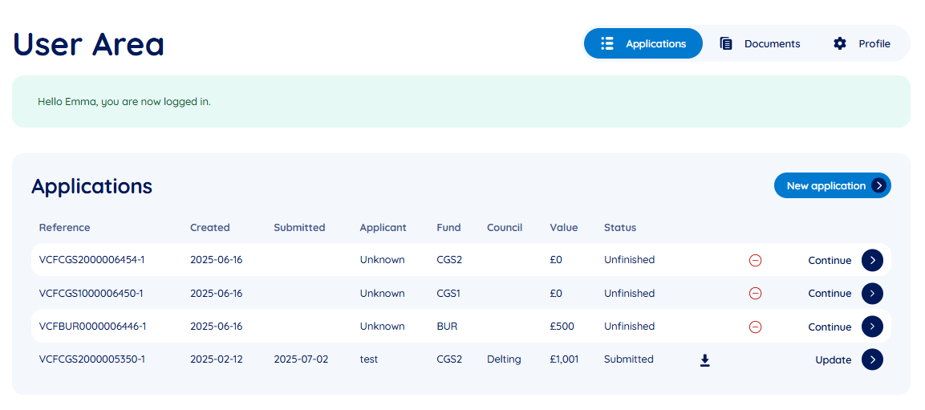

What happens next?

You will receive a confirmation email that your application has been received by SCBF. In some cases, we’ll contact you by phone or email to ask for any additional information needed, sometimes this isn’t necessary.

SCBF will check the eligibility, sustainability and achievement of fund priorities prior to sending Tier 1 and Tier 2 applications onto the relevant community council. A decision should be made and advised within 8 weeks of receiving your application. Any delays will be advised as soon as possible.

SCBF will issue successful applicants a grant offer letter with terms and conditions and will issue payment via BACS once grant conditions (if required) are met. Payments will either be in full or in instalments depending on the project's requirements. SCBF will support successful projects to complete monitoring and evaluation. If an application is unsuccessful you will be informed of the reason.

One-off grants must be spent within one year of award. Multiyear grant awards will be required to provide monitoring reports of their projects which detail evidence of successful outputs in order to release funding for the following year.

Application Details – Tier 2 and Tier 3

Contact Details

- Name of Group:
- This should be the name that appears on your group’s governing document and bank account statement.
- I am applying on behalf of:
- You will be able to select from a list – charity, group or individual.
- Contact name:
- This should be the person we address any correspondence to regarding the application, such as requests for further information or any grant offer.
- Correspondence address with postcode
- Telephone number – daytime and alternative:
- The number of the main contact on the application
- Contact email:
- This will be the email address we will use to send any correspondence regarding the application of the main contact on the application

Information about your organisation

- What are the main activities of your organisation and what service do you provide
- Charity/business registration number (where applicable)
- Number of people:
- How many members does your management committee have – not just office bearers
- How many regular volunteers do you have?
- If applicable, based on a 40 hr week, how many full-time equivalent staff do you employ and if successful, how many additional staff will you employ?

Financial Information (Tier 2 and Tier 3)

A copy of your most recent annual accounts must be included with your application. They should be signed by a member of your management committee. We will be unable to process your application if you do not send these or if your accounts are out of date.

Groups who have not yet completed one full year must contact SCBF prior to applying.

- What is your main source of income?
- E.g. local fundraising, grants, charges for services
- Please tell us what the difference was in your last year’s accounts between the money coming in and going out (your surplus or deficit) – these figures should match those in your approved annual accounts submitted with the application.
- Please also tell us about any unrestricted reserves you have and tell us if these cannot be used for the project you are applying for help with. (Unrestricted reserves are general funds held by the organisation, as opposed to restricted reserves which will have been provided by a funder or donor only for a particular purpose or project.)

About the project – Tier 2 and Tier 3

- Please describe the project you are applying for support for
- What do you want to do?
- How will you do this?
- Where will the project take place/what areas of Shetland will benefit?
- Who will lead the project? Their role(s), skills, experience.
- How will the project meet one or more of the funds objectives?
- Sustain and develop the local community
- Enhance quality of life for local residents
- Encourage community activity
- Evidence value for money and sustainability
- Describe the impact this project would make and the outcomes you intend to achieve
- How will you monitor and evaluate the success of the project?
- Describe the benefit to the community in the project
- How have they shown a need for this project now and in the future?
- How have they been engaged in the development of the project?
- How will they be involved in the delivery/implementation of the project?
- How will you maintain/sustain your project after the period of funding is finished? Will your project leave a lasting legacy?
- If the project will continue beyond the period for which you are seeking grant funding, please let us know how you intend to continue it, including how you will secure any funding, volunteers, or other resources needed to do so.
- Please also include relevant details if the project will help to make your organisation more self-sustaining.
- Is this a new project? If your project is already running, how has it been funded to date?
- Does your project require any permits or planning permission? If so, are these in place? (please provide evidence)

Project costs – Tier 2 and Tier 3

- What is the total cost of the project and how much grant funding are you requesting from the Viking Community Fund?
- Attach or enter a full cost breakdown for the project detailing which elements the fund would be supporting.
- Describe how you have sourced best value, i.e. multiple quotes
- If your total project cost requires other funding (including where your organisation is contributing its own funds), you will be asked to list all of the other funding sources, including the amounts being applied for and whether this funding is confirmed.

Downloading a copy of your application
In your user area you will find your applications (image below), click the button to download an overview of your applicaion, which you can save and share as needed.

What happens next?

You will receive a confirmation email that your application has been received by SCBF. In some cases, we’ll contact you by phone or email to ask for any additional information needed, sometimes this isn’t necessary.

Tier 2

SCBF will check the eligibility, sustainability and achievement of fund priorities prior to sending Tier 2 applications onto the relevant community council. A decision should be made and advised within 8 weeks of receiving your application. Any delays will be advised as soon as possible.

Tier 3

SCBF will check the eligibility, sustainability and achievement of fund priorities and will score your application against set criteria. An appraisal will then be drafted for a panel of SCBF officers who will make the final decision on whether to award any funding. A decision on your application should be made within four weeks of the fund closing date.

All Tiers

SCBF will issue successful applicants a grant offer letter with terms and conditions and will issue payment via BACS once grant conditions (if required) are met. Payments will either be in full or in instalments depending on the project's requirements. SCBF will support successful projects to complete monitoring and evaluation. If an application is unsuccessful you will be informed of the reason.

One-off grants must be spent within one year of award. Multiyear grant awards will be required to provide monitoring reports of their projects which detail evidence of successful outputs in order to release funding for the following year.

