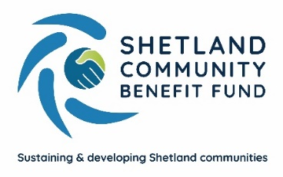
SCBF Investment Policy

Introduction
Shetland Community Benefit Fund are an independent community interest co-operative whose purpose is to negotiate and administer community benefit funding from renewable energy developers. SCBF currently administrate two community benefit funds, the Viking Community Fund and the Shetland Aerogenerators Community Benefit Fund.
SCBF distributes grants of between £50 and £200k+ up to a total value of £2,225,000 (index linked) per annum but this will vary year to year depending on grant making opportunities.
It is assumed that SCBF will hold a significant amount of funds pending disbursement for at least several months with a proportion of this being held for more than a year.
SCBF directors have delegated decision making on investment matters to the investment committee. The investment committee will comprise of the SCBF Treasurer, Fund Manager and two other directors.
Investment Objectives
SCBF wishes to maximise the value of the fund by holding some money in interest bearing accounts, fixed rate interest bonds and /or stocks or shares or investment bonds.
The aim of the investment would be for growth rather than income.
Liquidity Requirements
SCBF must maintain sufficient liquidity of funds to meet payment obligations when requested.
SCBF Directors have agreed to keep at least 50% of funds in investments that can be realised within 3 months.
Ethical Investment policy
The SCBF should choose to invest with a positive ethical choice favouring;
- Environmental benefit
- Societal benefit
- Companies paying at or above the real living wage.
SCBF should avoid investment in:
- Armaments
- Alcohol and tobacco
- Gambling
- Fossil fuels
- Companies with poor employment welfare
- Companies with poor environmental records.
Management, Reporting and Monitoring
Following examination of proposals from three suitably qualified companies SCBF have appointed an Independent Financial Adviser (IFA) to advise on long-term investment choices.
A review of this appointment will be made every 5 years by SCBF officers or at any other time if major material changes occur with either party.
Investment decisions will be made by the investment committee when required using online discussion and the recommendation of the IFA.
SCBF currently operates a cash management platform which acts as a hub with a variety of savings accounts within one platform. The aim is to hold no more than £85,000 in any of these savings’ account to ensure financial protection of funds.
For funds held in savings accounts, Fund Manager and the treasurer will move money between accounts to maintain a working balance in the current account.
For funds invested in stocks, shares and bonds the Independent Financial Advisor would liaise with the companies holding SCBFs investments, perform an annual check of performance of the funds and prepare a report for the SCBF Directors.
Independent Financial Advisor’s carry out due diligence on investors, routinely trade in investments and can secure preferential rates. SCBF aim to optimise the most efficient saving options balancing need for timely access, low risk of loss and growth of funds.

This policy will be reviewed annually by the audit and governance committee of the SCBF.

Date Issued – June 2025
Review date – June 2026

