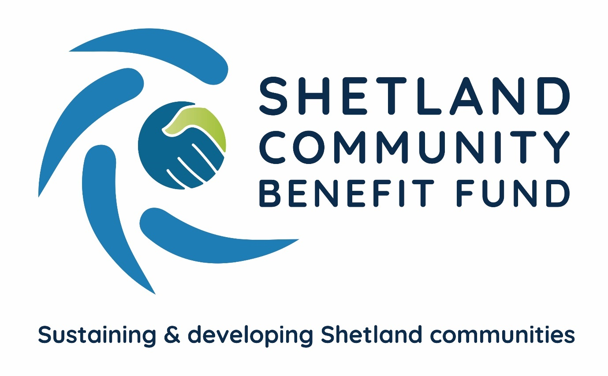

Directors Handbook

Contents
1 Shetland Community Benefit Fund – who are we and what do we do?
2 Community benefit agreements
2.1 Viking Energy
2.1.1 Heads of Terms and Minute of Agreement
2.1.2 Community Consultation and Business Plan
2.1.3 Viking Community Fund
2.1.3.1 Strategic Fund
2.3.2.2 Community Grant Scheme
2.2 Shetland Aerogenerators
3 The role of a director
3.1 Responsibilities of directors
3.1.1 Ensuring SCBF is carrying out its purposes for public benefit
3.1.2 Complying with SCBF’s governing document and the law
3.1.3 Act in the best interests of SCBF
3.1.4 Maintain Confidentiality
3.1.5 Manage SCBF’s resources responsibly
3.1.6 Act with reasonable care and skill
3.1.7 Ensure SCBF is accountable
3.1.8 Useful Links
3.2 SCBF officers and staff
3.3 SCBF membership and share certificate
3.4 Directors meetings
3.5 Sub-groups
3.6 Skills audit
3.7 Training
3.8 Declaration of interests
4 Important documents
Appendix 1 Management Sub-Committee TOR
Appendix 2 Audit and Governance Sub-Committee TOR
Appendix 3 Other Schemes Sub-Committee TOR
Appendix 4 Fund Management Sub-Committee TOR
1 Shetland Community Benefit Fund – who are we and what do we do?
Shetland Community Benefit Fund is a unique initiative with all the local communities coming together to benefit from commercial renewable energy developments in the islands. The islands’ 18 community councils formed SCBF as an independent co-operative to negotiate and administer community benefit funding from developers. It was agreed from the very start that, as far as possible, community benefits should be available on a Shetland-wide basis – so all local communities have a chance of accessing the funds. However, SCBF recognises that each agreement and how this aim is achieved, will be different.
2 Community Benefit Agreements
SCBF has reached two community benefit agreements, one with Viking Energy and the other with Shetland Aerogenerators Ltd. A SCBF sub-group keep in contact with other potential renewable energy projects throughout the isles on a regular basis.
2.1 Viking Energy
SCBF reached its first agreement in 2020 with the Viking Energy Wind Farm and its main shareholder SSE Renewables – for the largest community benefit fund for any onshore development in the UK.
2.1.1 Heads of Terms and Minute of Agreement
SCBF has signed a Heads of Terms with Viking Energy Wind Farm LLP (VEWF) and its major shareholder, SSE Renewables, setting out the framework for two legal agreements which will govern the payments from the Viking Community Fund (VCF) which will be administered and managed by SCBF. The HoT allows SCBF to provide grant aid, make investments, and loans.
The first Minute of Agreement was signed in 2020 and provides for a payment of £400,000 a year from the VCF to SCBF until 2024 or when the development becomes operational. The funds have been used to operate a grant scheme for projects that are supported by one of the islands' 18 community councils, for SCBF to administer the scheme and to develop its long term SCBF Business Plan for the VCF.
The second Minute of Agreement was signed in May 2024 and will release a VCF payment of approximately £2,215,000 a year (index-linked) for the lifespan of the development, currently estimated to be 25 years. This is largest onshore community benefit scheme in the UK.
2.1.2 Community Consultation and Business Plan
In October 2021, SCBF selected a preferred bidder to undertake a Shetland wide community consultation and prepare a business plan for the main Viking Community Fund. The consultation included a mail drop postal survey to all households in Shetland and engaging with community groups and businesses. From these surveys and engagement sessions, 6 strategic priorities for the fund emerged and were adopted by directors in October 2023. The business plan – ‘A Lasting Legacy for Shetland’ was published and widely circulated in May 2024.
The plan sets out how the Community Grant Scheme, which will replace the AGS, will operate and how the Strategic Fund will be distributed.
2.1.3 Viking Community Fund
During the construction phase of the Viking Energy windfarm, SCBF administered the Advanced Grant Scheme. The AGS divided funds between all 18 Shetland community council areas, with the four areas that have a Viking turbine within their boundary receiving five shares and the other 14 receiving one share.
When the windfarm became operational, the main Viking Community Fund of £2.2million per year began. There are two parts to the main fund - the Strategic Fund which focuses on projects that aim to tackle the 6 strategic priorities identified by the community consultation and a Community Grant Scheme which is very similar to the AGS.
2.1.3.1 Strategic Fund
Following a Shetland-wide community consultation, 6 strategic priorities for funding were identified and adopted by the SCBF board of directors. The strategic fund is for projects and initiatives which support one or more of the following priorities,
- More younger people wanting to stay/come back to Shetland
- Better Transport Links within and Between Communities
- Reduced cost of living in Shetland
- Better broadband and/or mobile phone connections
- Improved housing supply and affordability
- Preservation and Enhancement of Shetland’s natural environment
2.1.3.2 Community Grant Scheme
All 18 community councils are allocated funds from the Viking Community Fund on a share basis for the Community Grant Scheme (CGS). The areas hosting the wind turbines are allocated 5 shares and all others are allocated a single share.
The five-share areas are Delting, Nesting and Lunnasting, Sandsting and Aithsting and Tingwall, Whiteness and Weisdale and each has an annual allocation of £32,575.
Single share areas are Bressay, Burra and Trondra, Dunrossness, Fetlar, Gulberwick, Quarff and Cunningsburgh, Lerwick, Northmaven, Sandness and Walls, Sandwick, Scalloway, Skerries, Unst, Whalsay and Yell and have an annual allocation of £6,515.
Applicants applying to a specific community council area should complete a Tier 1 or Tier 2 application.
The Viking Community Fund has also allocated £135,000 to the CGS Tier 3 which is for applicants whose projects cover more than three community council areas. Tier 3 opens 3 times per year with £45,000 available during each round.
Projects looking for funding must ‘Sustain and Develop’ local communities.
2.2 Shetland Aerogenerators
SCBF and Shetland Aerogenerators signed a 10-year community benefit agreement in 2021 for £10,000 per year (index linked). In years 1 and 2, the funding was used for an active travel project. Funding in years 3 to 8 have been committed to supporting STEM activity with the purchase of scientific equipment to be used throughout Shetland schools and the relaunch of the Shetland Science Fair.
3 The role of a director
Each of Shetland’s 18 community councils can nominate a director for the SCBF board and they need not be a community councillor. Once elected to the board the director has a separate legal responsibility to SCBF. All directors are equally responsible in law for the decisions of the board. Therefore, all directors must act in good faith and act at all times with integrity and probity.
If a director is also a member of a community council, it is important that they undertake their SCBF role completely independently from their role on a community council – or indeed any other outside interests/responsibilities – and ensure they always act in the best interests of SCBF.
You may serve as a board member for three years before you must stand down. At this point you may seek re-election and serve for a further three years. This is detailed further in the SCBF rules found here.
3.1 Responsibilities of directors
Directors have legal responsibilities similar to those of a charity trustee.
3.1.1 Ensuring SCBF is carrying out its purposes for public benefit

You and your co-directors must make sure that SCBF is carrying out the purposes for which it was set up, and no other purpose. This means you should:

- ensure you understand the organisations purposes as set out in its governing document
- plan what SCBF will do, and what you want it to achieve
- be able to explain how all SCBF’s activities are intended to further or support its purposes
- understand how SCBF benefits the public by carrying out its purposes

3.1.2 Complying with SCBF’s governing document and the law

- make sure that SCBF complies with its governing document
- comply with law requirements and other laws that apply to independent co-operatives
- you should take reasonable steps to find out about legal requirements, for example by reading relevant guidance or taking appropriate advice when you need to

3.1.3 Act in the best interests of SCBF

You must:

- do what you and your co-directors (and no one else) decide will best enable SCBF to carry out its purposes
- with your co-directors, make balanced and adequately informed decisions, thinking about the long term as well as the short term
- avoid putting yourself in a position where your duty to SCBF conflicts with your personal interests or loyalty to any other person or body
- not receive any benefit from SCBF unless it is properly authorised and is clearly in the co-operatives interests; this also includes anyone who is financially connected to you, such as a partner, dependent child or business partner

3.1.4 Maintain confidentiality

You must:

- ensure you understand your responsibilities when handling confidential information
- demonstrate professionalism, good judgment, and care at all times in handling any information related to SCBF to avoid unauthorised or improper disclosures of confidential information.
- not share with anyone outside of the SCBF board, information which has been discussed confidentially or any legal agreements that are confidential.

3.1.5 Manage SCBF’s resources responsibly

You must act responsibly, reasonably and honestly. This is sometimes called the duty of prudence. Prudence is about exercising sound judgement. You and your co-directors must:

- make sure the co-operatives assets are only used to support or carry out its purposes
- avoid exposing the co-operatives assets, beneficiaries or reputation to undue risk
- not over-commit the co-operative
- take special care when investing or borrowing
- comply with any restrictions on spending funds or selling land

You and your co-directors should put appropriate procedures and safeguards in place and take reasonable steps to ensure that these are followed. Otherwise, you risk making the co-operative vulnerable to fraud or theft, or other kinds of abuse, and being in breach of your duty.
3.1.6 Act with reasonable care and skill

- must use reasonable care and skill, making use of your skills and experience and taking appropriate advice when necessary
- should give enough time, thought and energy to your role, for example by preparing for, attending and actively participating in all SCBF meetings

3.1.7 Ensure SCBF is accountable

You and your co-directors must comply with statutory accounting and reporting requirements. You should also:

- be able to demonstrate that your co-operative is complying with the law, well run and effective
- ensure appropriate accountability to SCBF members
- ensure accountability within the co-operative, particularly where you delegate responsibility for particular tasks or decisions to staff or volunteers

3.1.8 Useful links

Board responsibilities — NCVO Knowhow
Scottish Council for Voluntary Organisations (scvo.scot)

3.2 SCBF officers and Staff
The current officers for SCBF elected at the 2025 AGM are,
Chair – Chris Bunyan
Email – shetlandcommunitybenefitfund@outlook.com or Telephone - 07880 590 331
Vice-Chair – John Dally
Email - Jaydeewhalsay166@gmail.com or Telephone - 07780 926 072
Secretary – Alistair Christie-Henry
Email - aliunite@mail.com or Telephone - 07990 785 227
Treasurer – Aileen Brown
Email - medzet@aol.com or Telephone - 07483 299 646
Staff
SCBF currently employ two members of staff, a Fund Manager, and an Administration Officer.
The Fund Manager (FM) has overall responsibility for the management, development, financial and organisational support and services to SCBF.
The Administration Officer (AO) provides a range of clerical, administrative and financial support to SCBF.
Email – admin@scbf.org.uk or Telephone – 07538 417 175 / 07785 991 945
3.3 SCBF membership and share certificate
On election to SCBF, directors are asked to complete and return a membership form along with a one-off £1.00 membership fee. Once received, SCBF will issue a share certificate to the director. Members remain so for their lifetime unless they express in writing to SCBF that they no longer wish to be a member.
3.4 Directors meetings
SCBF meet on the second Wednesday of every second month in Lerwick. Attendees can join in person or via Zoom.. Meetings are scheduled to take no longer than 1.5 hours. The agenda, list of papers and meeting invite are sent to directors the week before the meeting. The aim is for any pre-meeting preparation of reading papers etc. to take no longer than half an hour. Please prepare by reading the papers prior to the meeting.
Only papers which are marked confidential or expressed as being confidential must be kept confidential.
If you are unable to attend the monthly meeting please send apologies to the SBCF staff – admin@scbf.org.uk or Chair – shetlandcommunitybenefitfund@outlook.com
3.5 Sub-groups
There may be times when you will be asked to join a sub-group working on a particular piece of work. This may be a topic of particular interest to you or where you have a specific skill which could assist in the work. Tor’s for each sub-group can be found as appendices to this document.
3.6 Skills audit
Following formal election, you will be sent a request to supply your professional and educational skills information to be added to a skills audit spreadsheet. Successful boards recognise and utilise the skills of their members where it is appropriate to do so. The skills audit also highlights where external advice may need to be sought.
3.7 Training
Directors are requested to undertake the ACAS Equality and Diversity online training. On completion, the certificate should be sent to the administration officer who will electronically file and register it.
SCVO also provide a wealth of online training for volunteers which can be accessed here - SCOPE eLearning platform – SCVO. Again, copies of any certificates should be sent to the administration officer for registering and filing.
3.8 Declaration of interests
Directors should familiarise themselves with the Declaration of Interests Policy and act accordingly in-line with its contents. SCBF publish their Declaration of Interests Register online on their website to ensure transparency.
4 Important documents
The following is a list of important documents which directors should familiarise themselves with,
SCBF Policies
- Data Protection Policy
- Data Sharing Document
- Safeguarding Policy
- Equality, Diversity and Inclusion Policy
- Health and Safety Policy
- Complaints Procedure
- Appeals Procedure
- Privacy Statement
- Conflict of Interest
- Financial Governance and Controls Policy
- Expenses Policy
Other important documents
- SCBF Rules
- Head of Terms Agreement with Viking Energy Windfarm (VEWF)
- Minute of Agreement with Viking Energy

Issue date – August 2026
Review date – August 2027

Appendix 1 Management Sub-Committee TOR

The Management Sub Committee is a sub-committee of the Management Committee.
Membership
The sub-committee shall consist of the Chair, Vice Chair, Secretary and Treasurer of SCBF.
Appointment of the Sub-Committee
The Management Committee shall at their first meeting following the AGM in each year, determine the members of the Sub-Committee until the next following AGM.
Casual Vacancies
The Management Committee from among their members shall fill casual vacancies occurring in membership of the Sub-Committee.
Frequency of Meetings
The Sub-Committee shall meet not less than 4 times in each year. A quorum at each meeting shall be 2 members. Discussion can also be conducted electronically with any discussion requiring input from all members.
Record of Meetings
The sub-Committee shall ensure that an agreed written record of any meetings and on-line discussions are forwarded to the management Committee prior to each general meeting of directors.
Staff Attendance
SCBF staff may attend a meeting at the request of the Sub-Committee, by their own request or on the recommendation of the Management Committee.
Functions of the Sub-Committee
The role of the sub-committee is to support the SCBF staff and chair in issues regarding the day-to-day management of the company and to provide advice and decisions, ideally unanimously, on matters regarding the running of the company and its various funding schemes.
If there is a disagreement on any issue whereby a unanimous decision isn’t possible the matter will be referred to the management committee.
However, on issues requiring an urgent decision but where there isn’t unanimity the chair can implement the majority view, if there is one, or the chair can make a decision and report to the management committee seeking retrospective approval for the actions.
The sub-committee will also consider longer-term issues regarding the management and running of SCBF and make any proposals it feels necessary to the management committee.
Appendix 2 Audit and Governance Sub-Committee TOR

The Audit and Governance Committee is a sub-committee of the Management Committee.
Membership
The sub-committee shall consist of a minimum of 3 members of the Management Committee. To ensure independence from the Management Committee, no officer will serve on the Audit and Governance sub-committee.
Appointment of the Sub-Committee
The Management Committee shall at their first meeting following the AGM in each year, determine the members of the Sub-Committee until the next following AGM.
Casual Vacancies
The Management Committee from among their members shall fill casual vacancies occurring in membership of the Sub-Committee.
Frequency of Meetings
The Sub-Committee shall meet not less than 2 times in each year. A quorum at each meeting shall be 2 members. Discussion can also be conducted electronically with any discussion requiring input from all members.
Record of Meetings
A report of the discussions and activity of the sub-committee should be prepared and agreed by all sub-committee members prior to presentation at any general meeting of directors.
Staff Attendance
The Staff may attend a meeting at the request of the Sub-Committee, by their own request or on the recommendation of the Management Committee.
Functions of the Sub-Committee
Scrutiny of the financial activity and systems of SCBF
Setting performance standards and auditing these.
Reviewing good governance and associated policies.
Considering appeals made to SCBF and agreeing an outcome.

Appendix 3 Other Schemes Sub-Committee TOR

The Other Schemes Committee is a sub-committee of the Management Committee.
Membership
The sub-committee shall consist of 3 members of the Management Committee.
Appointment of the Sub-Committee
The Management Committee shall at their first meeting following the AGM in each year, determine the members of the Sub-Committee until the next following AGM.
Casual Vacancies
The Management Committee from among their members shall fill casual vacancies occurring in membership of the Sub-Committee.
Frequency of Meetings
The Sub-Committee shall meet not less than 2 times in each year. A quorum at each meeting shall be 2 members. Discussion can also be conducted electronically with any discussion requiring input from all 3 members.
Record of Meetings
The sub-Committee shall ensure that an agreed written record of any meetings and on-line discussions are forwarded to the management Committee prior to each general meeting of directors.
Staff Attendance
Staff may attend a meeting at the request of the Sub-Committee, by their own request or on the recommendation of the Management Committee.
Functions of the Sub-Committee
Maintaining contact with renewable developers, the local authority and other relevant statutory bodies to highlight the possible roles of SCBF within any future development.
Promote SCBF and community benefits for all Shetland.

Appendix 4 Fund Management Committee TOR

The Fund Management Committee is a sub-committee of the Management Committee.
Membership
The sub-committee shall consist of a minimum of 6 members of the Management Committee.
Appointment of the Sub-Committee
The Management Committee shall at their first meeting following the AGM in each year, determine the members of the Sub-Committee until the next following AGM.
Casual Vacancies
The Management Committee from among their members shall fill casual vacancies occurring in membership of the Sub-Committee.
Frequency of Meetings
The Sub-Committee shall meet not less than six times in each year. This frequency will be reviewed annually. A quorum at each meeting shall be three members. Discussion can also be conducted electronically with any discussion requiring input from all members.
Record of Meetings
The sub-Committee shall ensure that an agreed written record of any meetings and on-line discussions are forwarded to the management Committee prior to each general meeting of directors.
Staff Attendance
Staff will attend all meetings.
Functions of the Sub-Committee
Overseeing the Strategic Fund and Community Grant Scheme
Overseeing development and delivery of strategic fund projects

